Portland Surf Life Saving Club
Junior Preliminary Skills Evaluation 2019/20
It is a requirement of Life Saving Victoria that ALL Nippers complete a preliminary skills evaluation prior to enrolling in the Nipper Program. If you are unable to attend any of our scheduled swim assessments, this form MUST be completed for each child wishing to participate and signed off by a qualified AUSTSWIM swimming coach/teacher.

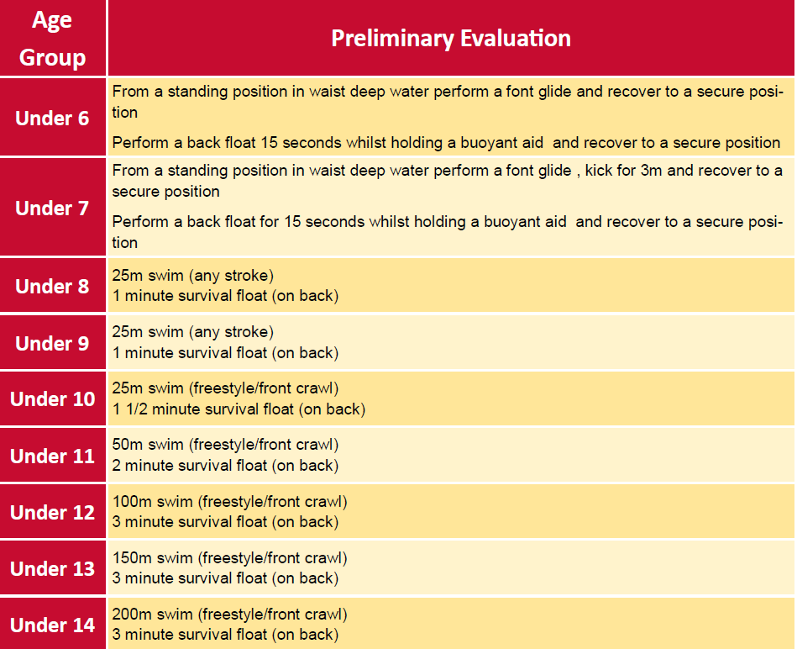

Swim Coach/Teacher name:………………………………………………………………………………………
Swim Club:……………………………………………………………………………………….
Signature:………………………………………………………………………………….…………………….. Date:………………………
Completed email it to portlandnippers@gmail.com or drop it in at one of the registration evenings at the green shed at Henty Park prior to Friday the 22nd of November.

